Question 1) simulation of peer to peer using packet tracer
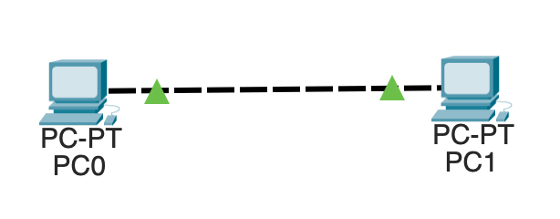

Step 1: Open Packet Tracer
- Launch Cisco Packet Tracer
- Click on Logical Workspace

Step 2: Add Devices
- From End Devices, drag PC-0 and PC-1

Step 3: Connect the Devices
- Click Connections
- Select the cross connection
- Connect: connect the both device with the cross connection through fast ethernet

Step 4: Assign IP Address to PC-0
- Click PC-0
- Go to Desktop inside the pc go to IP Configuration
- Enter:
  - IP Address: 10.10.10.1
  - Subnet Mask: 255.0.0.0
- Close window

Step 5: Assign IP Address to PC-1
- Click PC-1
- Go to Desktop inside the pc go to IP Configuration
- Enter:
  - IP Address: 10.10.10.2
  - Subnet Mask: 255.0.0.0
- Close window
Step 6: simulate the model and check the connectivity

